Assignment I

Deadline: Tues. 2 April 2019
1. A client attempts to synchronize with a time server. It records the round-trip times and timestamps returned by the server in the table below. Which of these times should it use to set its clock? To what time should it set it? Estimate the accuracy of the setting with respect to the server’s clock. If it is known that the time between sending and receiving a message in the system concerned is at least 8 ms, do your answers change?
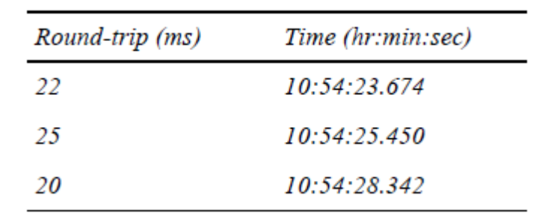

2. By using timestamp vectors to represent logical times, prove:
a) if neither T_{a} ≤ T_{b} nor T_{a} ≥ T_{b}, then a||b;
b) if T_{a} ≤ T_{b}, then a →b;
where T_{a} and T_{b} are timestamp vectors of events a and b, respectively.
Hint: 1) prove “if a →b, then T_{a} ≤ T_{b}” first; 2) then use “contradiction” to prove (a) (i.e., neither “a →b” nor “b →a” can be true); 3) using statement of (1) and (a), prove (b).

3. Suppose you’re the administrator of cs.cityu.edu.hk domain. What operations are required when:
- add a new host named “pluto” into the dept’l network.
- create a new sub-domain named “ds” in the CS domain and a host “ds0” is assigned to be the name server for domain “ds.cs.cityu.edu.hk”.
- change the dept’l www server to host “homer”.

